 |  |  | Statement of Work (SOW)
 |  |  | Electric Submersible Pump KPI Tracker
Requested by |  | Shane Wolf |  |  |  |  | Release ID | RLM000000014411
Prepared by |  | Wayne Green |  |  |  |  | Document No.**
Project Sponsor |  | Travis Swallow |  |  |  |  | Date Prepared | Jan 6 2023
Approval Authority* |  | Conventional ASC |  |  |  |  | Date Approved
Project Size |  | ☐ Small |  | ☒ Med |  | ☐ Large | IS Budgeted Amount*** | $ 106,400
SR&ED Eligible |  | ☐ Yes |  |  |  |  | Total Project Cost* | $ 151,853
Pre-Response Risk | M | Residual Risk |  |  | M |  | Four Year TCO* | $ 181,532

Statement of Scope

Executive Summary
This proposal is for the creation of a tool that will collect and evaluate information on ESP (Electric Submersible Pump) failures, reliability, performance and cost. The proposal is to build the ESP KPI Tracker as a progressive web application that features internal pages for data input and analysis as well as external web pages for suppliers to complete. The data will be kept in an Oracle database, and Power BI will be used for reporting and creating a dashboard. Currently, this process is performed manually in Excel, but in order to continue lowering our total cost of ownership and move from reactive to proactive management, we now need a more capable and focused solution. Subject matter experts can then concentrate on analysis rather than data administration thanks to a dedicated ESP tracker, which would also increase data quality and availability. Not that we do not use the information we already possess, but we would be gathering more information. CNRL is not currently utilizing predictive failure analysis on ESPs. The additional data collected by the new system would allow for all components that may have a failure indication but may have not contributed to the underlying cause of the failure. We are currently concentrating on the weakest link, but in the future, we will be able to detect faulty components before they cause a breakdown. Our objective is to use leading failure analysis, if we are able to gather additional data. With the addition of the Power BI dashboards, it is estimated that the solution will cost $151,853 and that the project will be completed in March 2024.

Background
Between 2018 and 2022, CNRL spent $126 million on connected ESP replacements and workovers, and there were 67 ESP pulls last year. The ESP committee has eliminated waste, improved runtime, and reduced costs so the easy wins are gone. If we want to continue reducing our total cost of ownership, we must use the vast amount of performance and maintenance data we have collected to identify emerging failure trends .Using several large, cumbersome Excel files, CNRL (Thermal and Conventional) currently records ESP reliability, cost, root cause investigation, KPI reporting, and real-time pump performance. The spreadsheet contains more than 3,800 events (installs, pulls and failures) going back to 1992. Since this is used by six different districts, there is no simple way to compile post-mortem failure data or lessons learned across the whole business. Excel places restrictions on the methods used to achieve quality control. Finding problems, manually entering data, and producing results takes a lot of time and is prone to data quality issues. Shane now personally purifies the data every two weeks by physically gathering all of the data from the six districts and carefully cleaning and consolidating the data into a single source. We considered various options, but none of the commercially offered solutions met our needs. The third-party software we looked at is used for ESP design and monitoring, not for cost analysis and KPI benchmarking. Their one-dimensional design makes them unsuitable for collective evaluations. We contacted our industry peers and Conoco has an ESP Tracker, which they built in-house and is not available for purchase.
By interviewing Ross McNaughton and Peter Uwabor, I examined the possibility of repeating the work done by the PC Pump venture. Ross said that the projects are considerably different for a variety of reasons, including the design of the pumps. PCPs are utilized in heavy oil conventional applications, whereas ESPs are employed in thermal applications. The PCP initiative relied on Machine Learning, whereas the ESP project is creating a front end to replace Excel. Finally, he said it is like comparing a Toyota to an F1; they are both automobiles, but they are vastly different. The Engineers did not utilize the PC Pump dashboards, according to Peter, since there was no desire to do so. The engineers said that they already knew what pumps they intended to use, and as a result, there were no users in the first three months of the dashboard's creation.
After speaking with Oliver Tozser, it was determined that the majority of Conventional Districts only monitor large items in Maximo, like compressors, vessels, and skids. Currently, they do not even capture pump jacks, and there are no plans to record any pumps.

Scope
Included | Excluded
- Development of Oracle database  - Data migration from Excel to Oracle  - ESP vendor data loading method development  - Data administration interface  - Training materials for vendor support  - Data validation and cleansing  - Data views for Power BI reporting  - Power BI Reports developed by Thermal Data Management (TDM) team  - Advanced analytics incorporated by TDM to be used in the Power BI dashboards | - Machine Learning  - Provisioning servers or other hardware

Assumptions, Constraints, and Dependencies

Assumptions | Constraints | Dependencies
- One data loading method can be used by all vendors  - Web service will be used to gather vendor data  - BSA will act as project manager  - Resources to develop analytics tools will be provided by the Thermal Data Management team | - Budget  - Availability of SMEs to provide guidance and testing  - Engagement level of the ESP vendors  - Thermal Data Management team’s availability  - Developer availability | - None

Deliverables
- Migration of existing ESP data to Oracle
- Process for loading vendor data
- Data administration editor
- Support documentation for vendor data loading
- Provide data views to facilitate Power BI dashboards
- Power BI dashboards

Acceptance Criteria
- Vendors are able to load data without manual intervention
- Able to view and update data via the manual editor
- Able to stop using existing ESP spreadsheets

Stakeholders

Stakeholders | Interest/Requirement | Consulted/ Reviewed
Travis Swallow – Business Owner | Sponsor | ☒
Patrick Nolan | Champion | ☒
Shane Wolf | Champion / SME | ☒
David Hill - Infrastructure | Database | ☒
Emily Pegg | Developer | ☒
Erika Robles | Developer | ☒
Cam McDonald | Power BI reporting | ☒
Shawn Darrah - Ops Architecture | IS work must align with IS roadmaps, strategies and services and follow the IS Cybersecurity Framework and Operations Technology Standards. | ☒

Project Schedule
Schedule Constraints
- Emily is on rotation for January and February
- Resources are at 50% capacity, 2nd Developer is at 25% and Power BI is at 20%

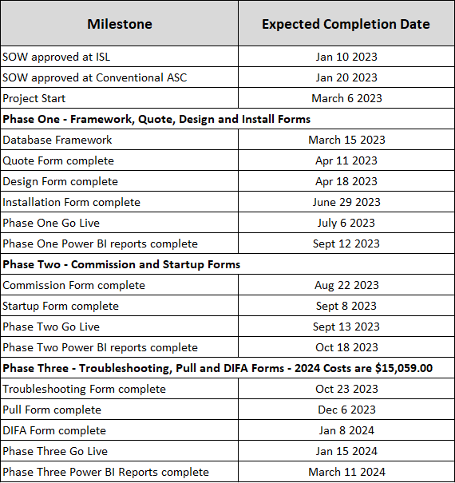

New Schedule (Aug 26 2024) : See PCR002 for details: \\cnrl.com\cnrl\depts\cgy-admn\Development\Conventional Applications\Projects\ESP\4 - Business Analysis\Project CRQ\Project Change Request - ESP KPI Tracker - PCR002.docx

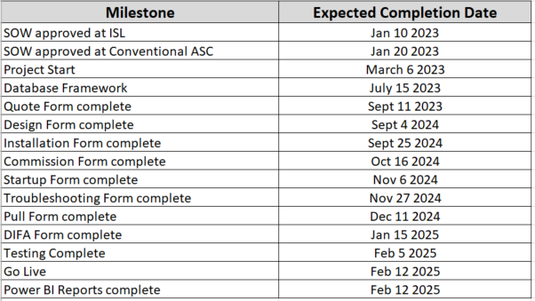

Business Case

Value Analysis
Table 1: Value Analysis Spreadsheet (Embedded)

Procurement

Procurement Type

☐ Sole-Source
☐ Single-Source
☐ RFI
☐ RFP
☒ N/A

Rationale (bullet point form)
- Staff resources will be used to develop the solution in-house.

Benefit Statement
Factors | Details
Cost avoidance | - Maintaining production by avoiding downtime adds $48,000 (600 BOE/d x 4 days x $20 per barrel) for a Thermal well.
Cost Reduction | - 67 ESP pulls cost $15,472,855. If we can reduce that by one ESP failure, we would save $230,938.13. $160,000 for a pump and $70,938.13 for a rig.
Risk Assessment | - The present Excel workbook is comprised of a unique collection of worksheets and is prone to crashing because of its reliance on macros to manage data. It might collapse, become corrupt, or have a supporter leave the organization. The effort required to construct the workbook may be used to determine its worth, which was $307,200 (12 years x 10% of 2,000 hours x $128/hour).  - Cost is $307,200 x likelihood (0.01) = $3,720
Productivity Gains | - Productivity gains will be achieved in the following areas, resulting in 60 min a day in saved time. (4 days a week x 48 weeks x $128/hr = $24,576)  - Data entry  - Data sanitation  - Eliminate repair work required on excel workbook  - Combining District tracker data  - Analysis  - More comprehensive component analysis

Project Risks

Risk | Risk Level | Risk Responses | Residual Risk
Business Process  ☐ Significant change to business processes  ☒ New integration of business process  ☐ Low maturity of existing business process  ☐ System cannot be modified to match business process  ☐ SMEs not involved in tool selection  ☐ Requirements changing or are prone to change | Moderate | ☐ Detailed use cases, business requirements, and business processes defined and reviewed by business  ☒ Estimates contain contingency  ☐ Customer References completed  ☐ Dedicated Business Architect appointed  ☐ Dedicated Solution Architect appointed  ☐ Dedicated Organizational Change Manager appointed | Low
Technical  ☐ New technology  ☐ Staff new to technology  ☐ New Infrastructure systems not used at CNRL  ☐ Data conversion complicated  ☐ Data Integration complicated  ☐ Security requirements complicated  ☐ Base software must be modified  ☐ SaaS-based solution |  | ☐ Proof of Concept in budget  ☐ Budget includes 3rd party experienced consultants  ☐ Vendor commitment planned for after Proof of Concept  ☐ RFI completed  ☐ Customer References completed  ☐ Solution Architect appointed  ☐ Data conversion review completed by data conversion team  ☐ Data integration review completed by data integration team  ☐ Security review completed by security team  ☐ Technical teams appointed to review feasibility of customizations  ☐ Time included for customizations even if configuration only anticipated  ☐ SaaS questionnaire evaluation at or below “Medium” risk  ☐ Budget includes IS Staff Training for new technologies
Project Team  ☐ Team contains junior staff in key roles  ☒ Project is not team’s main priority  ☐ Is not in the Top 5 budget size projects in IS | Moderate | ☐ Budget contains training for team  ☒ Estimates consider skill level of proposed team  ☐ Budget contains 3rd party experienced consultants  ☐ Dedicated Project Manager(s) appointed  ☐ Dedicate resources  ☐ Manager guarantees priority over other workload  ☐ Backfill in budget to reduce project team’s workload | Low
Vendor  ☐ Vendor is new to us  ☐ Vendor has not delivered a similar solution on this scale  ☐ CNRL lost negotiation on a key contract item  ☐ Vendor has a small customer base  ☐ Demo did not use base software |  | ☐ Vendor Analysis completed  ☐ Vendor References completed  ☐ Vendor commitment planned for after Proof of Concept  ☐ Contract negotiated as fixed price  ☐ If T&M, then payment is linked to delivering specific milestones  ☐ If T&M, then cost/time overruns terms defined  ☐ If T&M, then a change control terms defined  ☐ Contract contains "Opt Out" or "rebate per bug" clauses  ☐ Budget includes 3rd party experienced consultants  ☐ Demo used live environment
General  ☐ Past project not used for comparison  ☐ Project team did not provide estimates |  | ☐ Business case tolerant to 50% contingency  ☐ Contingency plans for residual risk  ☐ Schedule and cost considers previous projects  ☐ Schedule review completed by objective schedule review panel
☒ Data loading is contingent on engagement of ESP vendors | Moderate | ☒ Early engagement and communication with vendors | Low

